**Introduction**

**What is this policy?**

This document is a way to capture how the organisation wants to make decisions together. It assumes that decisions within the organisation will aim to be made by **consensus** - that is, when everyone involved is willing to go ahead with a decision, rather than simply a majority vote - at whatever level is appropriate for the particular decision.

This document also aims to answer the following questions:

1. What shared beliefs should underpin the ways the organisation makes decisions?
2. What types of decisions should be able to be made by different groups within the organisation?
3. What are the steps in consensus process that we will follow when making decisions?
4. What if we’re not sure who should make a decision?
5. What tensions might we struggle to balance in decision making?

**Why and how was it written?**

This policy was developed in 2021-2022, because of confusion that had come up around how the organisation should make different types of decisions and who should be able to make them. Working with XXXXXXXX, members went through a series of workshops to:

1. Learn how to make decisions using consensus decision making process,
2. Identify shared beliefs about how decisions should be made in the group,
3. Decide which different parts of the organisation should be making what decisions, and
4. Explore the gaps and tensions that were likely to arise around decision making.

This document is a draft, to be agreed in full. It also suggests some areas where future work is needed. Hopefully the organisation members who have been a part of this process can share the learning that has happened with other members who weren’t as involved.

**Principles**

This policy is based on shared beliefs within the organisation about how decisions should be made. These principles aim to capture what those beliefs are. In moments where it’s not totally clear who should have the power to make a particular decision, or what should inform that decision, the group can look back at these principles and they will hopefully help guide how the decision should be made, and by whom.



**Accessibility** - Supporting as many people as possible to take part in decisions  
This could mean:

* Translation into different languages (Of documents before meetings and of discussions during them)
* Thinking about where meetings will happen? (Online / offline)
* Supporting people to be active in discussions prior to decision making
* Recognising that different people will need different things to take part.

**Participation -** Making sure everyone who is likely to be affected by a decision is consulted or directly involved  
This could mean:

* Thinking about if this is a decision that others need to be active parts of, or if being informed, with a chance to feed back their opinions, is likely to be enough
* Publicising meetings on the right WhatsApp groups so people aren’t excluded e.g. the organisation’s Announcements group if you want to reach everyone.

**Time** - Making sure we have enough time to have the discussion well   
This could mean:

* Giving a whole meeting or multiple meetings to an important decision
* Planning for important decisions well in advance (3 days minimum), so people have time to get informed about them and develop their own opinions

**Active Listening** **-** Listening to and respect each other - not just going with the loudest voices  
This could mean:

* Proactively making space for disagreement
* Remembering that sometimes we have to compromise
* Checking if everyone involved has had a chance to be heard

**Clarity** - Knowing who can make a decision and how the decision is made  
This could mean:

* Checking this policy to make sure the decision is being made by the agreed group within the organisation
* Continuing to share learning across the organisation about consensus decision making, so more members know how to be part of it
* Remembering to use consensus process, even if it feels a bit strange, so everyone is on the same page about how the decision is being made

**Communication** - Telling people about upcoming decisions and decisions that have been made  
This could mean:

* Using multiple forms of communication (ie - WhatsApp groups, phone calls, personal messages) to let members know when decisions are coming up that may affect them
* Making sure people have the information they need to be a part of the discussion, before the discussion
* Making sure the decision and the reasons for the decision are communicated clearly to everyone else

**Capacity** - Assessing if the group has the time and energy to implement a decision, before it has been made  
This could mean:

* Thinking about capacity of the group / of volunteers before the discussion / decision and checking in with them
* Agreeing who is going to follow it up, once a decision is made
* Sharing the action points around a decision with several people, so it doesn’t just land on one person to make it happen

**Who Makes What Decisions?**

The session in January explored the different types of decisions and who can make them. There were a lot of different decisions that came out, so XXXXXXX has attempted to synthesise these into broader example types of decisions for each area and a ‘general rule’. When making decisions at any level, members are encouraged to consult the other members of the group that will be making the decision (ie - the working group, or all of the organisation), before the decision is made, to help ensure that as many members as possible have had a chance to input, even if they are not around at the meeting where the decision is made. **A section on ‘Trustee decisions’ will be added shortly.**

1. **I can make this decision as an individual**

The General Rule:

*Individuals can make decisions that affect them and about how to carry out responsibilities and tasks that have been delegated to them from a bigger group within the organisation.*

What are some examples of those decisions?

* How much time to give to the organisation
* Which working group to join
* How to carry out action points

1. **Specific roles can make this decision - e.g. the person doing emails, or a finance person**

The General Rule:

*Specific role holders can make decisions that fit within their role , with guidelines as to what that entails.*

What are some examples of those decisions?

* Doing social media posts
* Answering emails
* Compiling meeting agendas

In cases where these decisions aren’t clear or have the potential to impact others in ways that aren’t anticipated by these guidelines, role holders should consult some of those who might be impacted for input. Guidelines may state that consultation is part of the decision making process e.g. when compiling agendas this should be done through consultation with others who will be in a given meeting.

1. **A working group can make this decision**

The General Rule:

*Working groups can decide how to structure themselves and how to work together. They can also decision how best to carry out activities that they’re set up to do.*

What are some examples of those decisions?

* The kids space decides how best to run the kids space
* Change policies about things that are within the remit of the working group e.g. the kids space can change the safeguarding policy.
* Who can be in the working group and recruitment
* Spending on working group activities within an allocated budget

1. **The whole of the organisation needs to make this decision together**

The General Rule:

*Everyone needs to make the decision together when:*

* *It’s about the strategic direction (aims and vision of the organisation)*
* *It’s something that will affect many people in a big way (e.g. - a major new policy)*

What are some examples of those decisions?

* What are the kinds of grants we’re OK to apply for? Is it OK to take money from councils or businesses?
* What are the rules and accountability guidelines in the space?
* What are the criteria for the money we give in grants?
* When to reopen the space after long periods of closure?

1. **We should consult people outside of the organisation (e.g. another group we work with)**

The General Rule:

*We consult other groups when:*

* *The work affects other communities*
* *We’re collaborating with other groups*

What are some examples of those decisions?

* About collaborative projects
* About joint public statements on shared issues

**How Are Consensus-based Decisions Made?**

Decisions in the organisation should aim to be made by consensus. This means finding agreements that everyone is ok with, rather than agreements that the majority (whether it’s 51% or 99%) would make as their first choice. There are several reasons the organisation has chosen to make decisions in this way:

1. **Sharing power:** Consensus process gives more people a say in what the group does and doesn’t do. This helps to ensure that power is distributed across more members of the group, rather than just being held by a few people.
2. **Making better decisions:** When more members of a community have been involved in making a decision, they will usually be more invested in the decision, than if they’d felt sidelined or ignored by the decision making process. When people are more invested in decisions, they usually stick to them and take clearer steps to help make sure they get implemented.
3. **Building community:** Making decisions by consensus means making efforts to get everyone involved - so the process of doing so builds stronger relationships amongst members of the group, as people actively work to hear one another’s opinions. It also helps build individual members’ sense of involvement and ownership in the decisions, which can help them to feel more invested in the community.
4. **Protecting minority needs and opinions:** Consensus process doesn’t assume that just because more people in a group want a particular decision to be made, than the needs of those who want something different are any less important. It makes space to find constructive compromises, rather than forcing those with less-popular opinions to go along with the majority. It also helps the majority within a group to understand needs that are different to their own.

In order to practice these ideas, there are clear steps that the organisation members should aim to take together when making decisions. They often feel a bit ‘clunky’ when you’re not used to them, but sticking with the steps, they gradually start to feel easier:

1. **Frame the problem:** What is the issue that the group wants to address?
2. **Explore the topic:** What are the different ways the group could address this issue?
3. **Underlying concerns:** Are there any concerns around the ideas that are coming forward from the group?
4. **Develop proposal:** What does the group feel should be done, which can address the different concerns that were raised? (If a proposal is already formed before the meeting, you can start with Step 4)
5. **Agreement/opinion check:** How are people feeling about it? Can do a go-round to ask everyone, or use hand signals (ie - hands up for support, hands down for opposition, hands in the middle for mixed feelings). If there are still strong objections, the group should work to reshape the proposal.
6. **Decision:** If the temperature check hasn’t brought any strong objections forward, the group should formalise the decision (and the facilitator should be clear that this is not just an opinion check!) A decision is made by all members indicating a ‘Fist-to-Five’ opinion on the proposal, where everyone shows a number of fingers, based on their feelings about the proposal (or types the numbers 0 to 5 in the chat).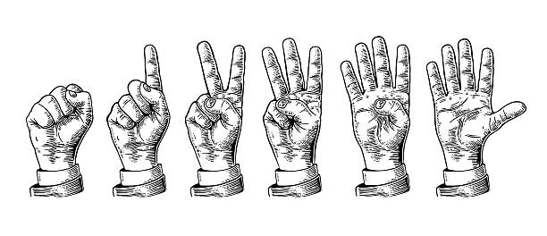
   1. **3-5 fingers** **= consent** (these indicate medium-to-strong support)
   2. **2 fingers** **= stand aside** (a stand aside means that someone doesn’t feel equipped to make a decision but trusts others to do so)
   3. **1 finger** **=** **disagree** (indicates that someone doesn’t like the decision, but is not worried that it is a major problem if it goes ahead. If someone presents a 1, other members should always check in with them, in case there are additional steps that might help them feel better about the proposal)
   4. **0 = block** (this is an indication that someone in the group feels the current proposal is at fundamental odds with the values of the group and must be re-evaluated. If someone in a group uses a block, they need to be prepared to explain why they have done so [ie - what values are being violated], and it means that the group must start on a new proposal.)   
      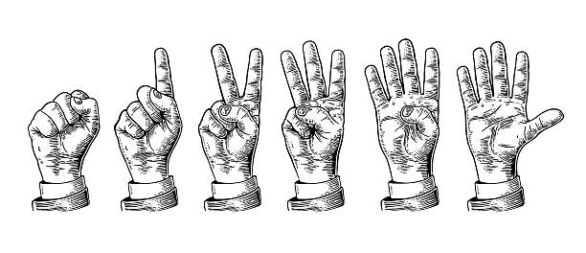
7. **Closing:**
   1. **Addressing a situation where not everyone is super happy:** If there have been any stand-asides, think about what is needed to help those who haven’t been as strongly in-favour of the decision to stay involved and invested in the group. Often someone making time to talk to them one-to-one afterwards, to listen to their needs, can help with this.
   2. **Agreeing particular action points and actually doing the thing:** Leaving time in the meeting for members to think through the next few steps needed to implement a decision together, and then getting multiple people committed to the action points involved in the follow-up steps.

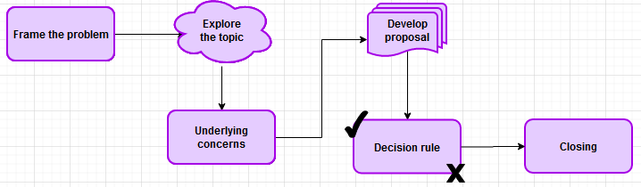

**What if we’re not sure who should make a decision?**

*What do we do when we aren’t sure who should make a decision?* Ask someone else (from another part of the organisation) for their view on who should make the decision!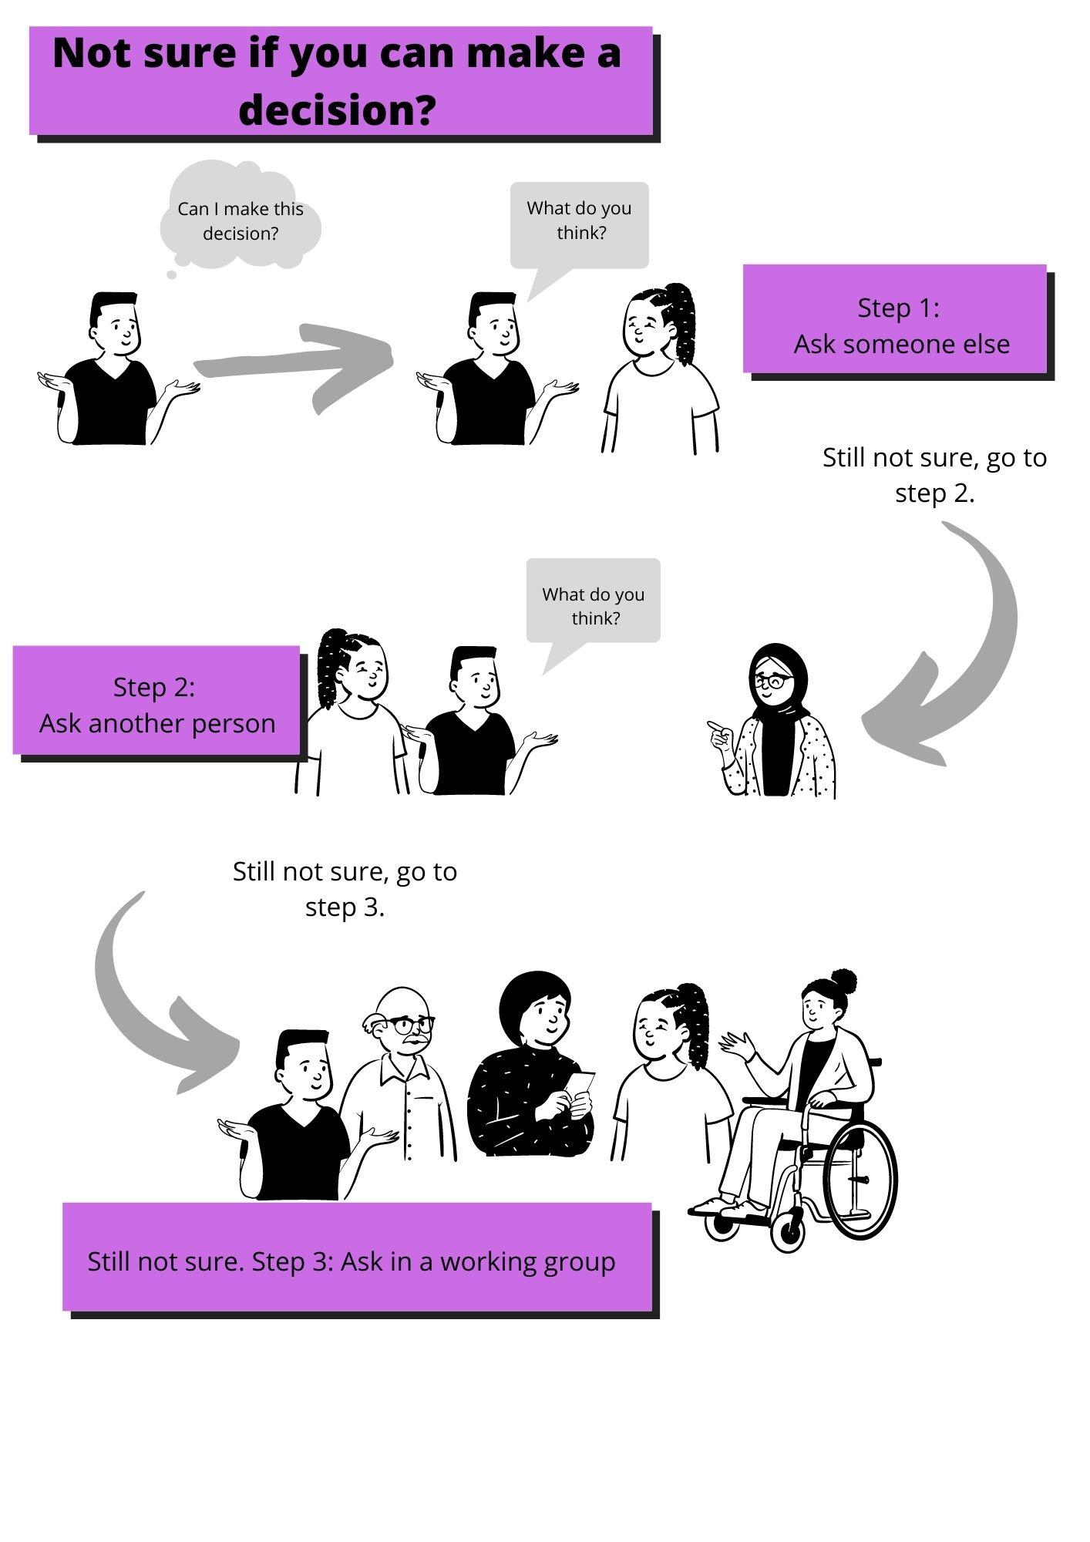

*What do we do if both of us aren’t sure who should make the decision?* Ask someone else again!

*What do we do if all 3 of us aren’t sure who should make the decision?* Bring it to your next working group meeting to clarify who should make the decision! (And potentially make the decision, too!)

**Appendix: Decision making record table**

| **Date of decision** | **Part of the organisation that made the decision** | **The Decision** | **The reasons for the decision** | **Who you can ask about the decision?** |
| --- | --- | --- | --- | --- |
| *8 March 2022* | *X Working group* | *To make a decision making record table* | *So there’s a log of what decisions have been made by who* | *Samir or Diane* |
|  |  |  |  |  |
|  |  |  |  |  |