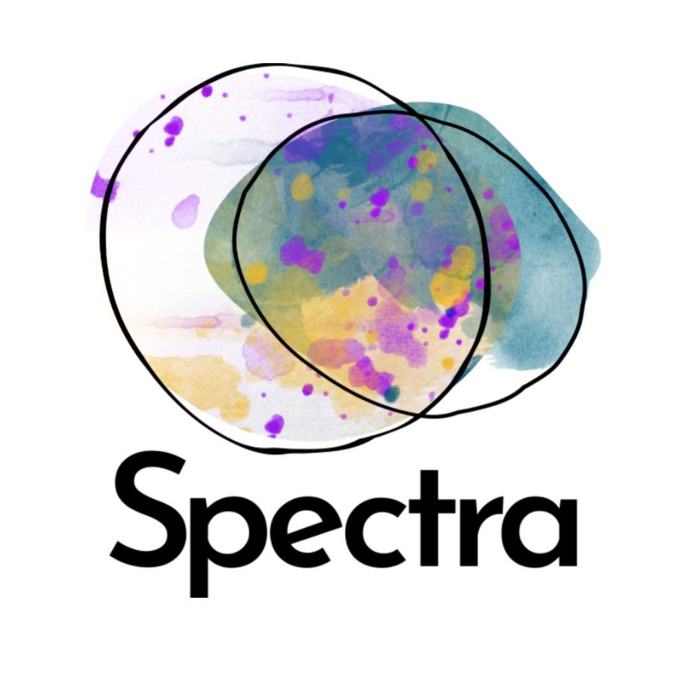Details of Employment

**Name**: NAME (you, the employee)

**Address**: ADDRESS

**Employer**: Spectra Arts CIC (we, us, the company)

**Your Period of Continuous Employment began on**: DATE

Our approach to our employment relationships aims to recognise hard-fought employment rights. We ask you to consider the protection that they intend to create – protection from over-work, from under-pay, from ill treatment, discrimination, unfair dismissal – and our community depends on you upholding these in our day to day practice and helping all of us to do the same.

This document is designed to make it easy to understand the key elements of your employment with us. The overall employment contract is made up of the Details of Employment, Employment Terms, and the Core Team Roles - where your specific responsibilities, along with the rest of the team's, are listed. All documents will be discussed during onboarding.

| What will Spectra do for you? | Flexible working |
| --- | --- |
| Unlimited annual leave |
| Mental health days |
| £400 wellbeing fund |
| Professional development fund |
| 4% pension contribution |

Your Role: TITLE

| **Start Date**  DATE  **End Date**  DATE  **Mutual Trial Period**  XX weeks | **Notice Period During Mutual Trial Period**  4 weeks  **Notice Period After Mutual Trial Period**  8 weeks | **Statutory Annual Leave**  28 days pro rata including Bank Holidays. For this role, this equates to XX days. |
| --- | --- | --- |
| **Location**  Work from home or from Co-Working Space (ADDRESS) | **Support Contact**  NAME  (ROLE) | **Working Hours**  XX hours  (i.e XX days a week) |
| **Base Salary**  £30,000 per annum pro rata. For this role, this equates to £XX per year before taxes, national insurance and pension contributions. | | |

# Employment Terms

| **Working Hours** |
| --- |
| For reference, our standard office hours are Monday-Friday 9.30am-5.30pm, but the allocation of your hours is very flexible, taking into account natural fluctuations of work flow. Unless either of us is concerned that you are consistently working over or under your hours, it is not necessary for you to track your hours. We will check in monthly about whether this allocation feels appropriate and you are encouraged to raise any thoughts or concerns at any time.  Due to the flexible and self-managed approach to working, we do not operate a formal time off in lieu (TOIL), and instead expect you to vary your hours as needed for your schedule and to take time off when it is needed in agreement with the team. |

| **Location** |
| --- |
| We have one co-working day in the office per week (normally Tuesdays). Otherwise, you will work from home. Your role may also require you to work elsewhere if you are delivering activity. |

| **Salary** |
| --- |
| Your Base Salary will accrue from day to day at a rate of 1/365 of your equivalent full-time annual salary and be payable in arrears on the last Friday of each month. In April each year, your Base Salary will increase by at least 3% to take into account inflation and the rising cost of living. |

| **Mutual Trial Period** |
| --- |
| This is an important time for both parties to see if there is a strong mutual fit between us, the role and the work. Before the end of the Mutual Trial Period, both parties will be invited to reflect and confirm if we believe this relationship is generative to continue beyond the Mutual Trial Period. This will take the form of a check in between you and your Support Contact where feedback will be given to you, and you are invited to feedback too. |

| **Support Contact** |
| --- |
| We do not have a traditional line management system, but your Support Contact is there to go through onboarding, discuss your work and discuss any issues or concerns. Please raise issues and concerns in a timely manner so that we can address them promptly and prevent them from becoming bigger. If you want to undertake professional development or use the wellbeing fund, let your Support Contact know. |

# Employment Terms - Benefits

| **Flexible Working** |
| --- |
| Equipment for safe home working can be provided if required, at the company’s cost (to be returned to the company at the end of the contract as agreed). |

| **Annual Leave** |
| --- |
| The holiday year is 01 April - 31 March.  Statutory Annual Leave is the minimum annual leave you are legally required to take (pro rata) during the year. This includes a pro rata Bank Holiday allocation. However, we offer unlimited agreed leave which means additional leave beyond the legal minimum is available to take as needed, as long as it is agreed with your Support Contact and you can ensure your work is not going to be jeopardised by the time off.  If you plan to be away from work:   * for one day or less, ask your Support Contact at least one week before, let colleagues know asap and mark it on our shared calendar. * for a full week or more, ask your Support Contact at least two weeks advance, inform colleagues as above, and arrange any necessary cover of responsibilities. * for three weeks or more, ask your Support Contact before booking so that we can ensure the extended absence can be supported by the rest of the team. |

| **Mental Health Days** |
| --- |
| These do not need to be booked in advance as they can't always be planned, but as much notice as possible is helpful for the rest of the team. You will have a gentle check in with your Support Contact when you return to discuss any support we can offer. A deeper check in is available when you decide you are robust enough for that. If it feels like your mental health is impacting your ability to fulfil your role, your Support Contact will speak with you about support strategies and whether it is appropriate for you to continue in your role. |

| **Sick Leave** |
| --- |
| Paid Sick Leave is unlimited but monitored to ensure you and the wider team are able to manage workload sustainably during periods of sickness. If you are unwell for 7 consecutive days or more, please obtain a doctor's note and send it to your Support Contact. If you have taken 10 or more sick days in 12 months, your Support Contact will meet with you to figure out how you can be supported to remain fit to work. |

| **Wellbeing Fund** |
| --- |
| This can be used for activities that support your good emotional, mental and physical wellbeing, including counselling. |

# Some Other Important Stuff You Should Know

| **Pre-Conditions of Employment** |
| --- |
| As an employer in England, we are legally required to ensure you are entitled to work in the UK. By signing this contract, you are confirming that you are entitled to work in the UK without any additional approvals, and will notify us immediately if this changes during your employment. If we ask for references, your employment may be conditional based on these. Any potential issues that arise from your references will be discussed with you before a decision is made. |

| **Termination** |
| --- |
| For detailed information, please see our Disciplinary Policy. The key points have been outlined here. In the following cases, immediate termination of this contract (initiated by either party) may apply.   * Repeated failure to carry out your duties as outlined in Spectra Core Team Roles*, or consistent missed deadlines**. * Consistent failure to support you to effectively carry out your role***. * Gross misconduct, including health and safety breaches. * Actions which may cause reputational, financial or social harm.   * where the failure has caused reputational, financial, or emotional damage to team members or the company more than three times  ** three missed deadlines, consecutively  *** three or more separate instances  In order to avoid immediate termination whenever possible, the following procedure will be carried out before this decision is made.   * Any instances of our failure to support you should be raised with your Support Contact as soon as they arise to come to a mutual understanding of the situation and plan how this can be avoided in future. This can be in person, over the phone or over email. * Similarly, any instances of your failure to carry out your duties or missed deadlines will be raised by your Support Contact as soon as they arise to come to a mutual understanding of the situation and plan how this can be avoided in future. |

| **Location of Work** |
| --- |
| Due to the legal implications and risk involved, residing and working outside the United Kingdom without written agreement in advance could result in termination of this contract under law. Legally, we must highlight that both employees and employers may have social security and tax obligations in countries where you work and reside and therefore it is essential that any plans to live or work abroad are raised and assessed in advance if they are to occur. This should be raised at least 3 months before the planned move. |

| **Intellectual Property** |
| --- |
| We have a culture of collaboration at Spectra, which means that all the work we do is the result of many minds. The intellectual property rights in any work produced under the company’s banner therefore belong to the collective, Spectra. We will always give credit where it is due, unless agreed otherwise. If you wish to use anything belonging to Spectra in future, you must obtain written permission from Spectra and credit us. |

| **Data Protection** |
| --- |
| We will collect, process and securely store information relating to you in accordance with the Privacy Policy and Data Protection Policy. During onboarding, you are required to sign and date the Privacy Policy and return it to your Support Contact. |

| **Confidentiality** |
| --- |
| You agree you will not: make any statement (written or oral), provide material for publication by television, radio, film web or other similar media, or write any book or article or otherwise publish (regardless of the medium of such publication) any matter on or relating to the affairs of the company or the wider group, including any matter relating to a partner, customer, client or other person connected to us which came to your knowledge during performance of the services, during or at any time after the termination of the period of your employment without written permission from the Company. Agreeing to this will not prevent you from making a disclosure as required or protected by law. |

# And Finally…

Detailed information on the following topics can be found in the policies on our website. These

policies do not form part of your Employment Contract but help to inform our company culture.

Environmental Policy and Action Plan, Anti-Racism Policy and Action Plan, Disciplinary Procedure, Grievances and Complaints, Data Protection (GDPR), Privacy, Safeguarding, Bullying and Harassment, Equal Opportunities, Recruitment and Appointment, Covid-19

# Happy?

| Employee  Name:  Date:  Signature: | Employer  Name:  Date:  Signature: |
| --- | --- |